Coordination of Entrepreneurs (2022)
WP3/ Development/3.2. «Entrepreneurs Centres»

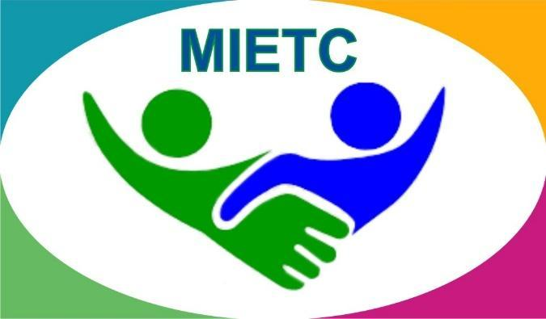
DEVELOPMENT OF A MASTER PROGRAMME IN THE MANAGEMENT OF INDUSTRIAL ENTREPRENEURSHIP FOR TRANSITION COUNTRIES
610198-EPP-1-2019-1-ES-EPPKA2-CBHE-JP

The information and views set out in this publication are those of the authors and do not necessarily reflect the official opinion of the European Union. Neither the European Union institutions and bodies nor any person acting on their behalf may be held responsible for the use which may be made of the information contained therein.

Detailed information is available in the Handbook
https://www.keu.kz/en/section-table/31-materialy/10080-handbook-of-the-entrepreneurs-center.html

Employment of graduates: new facets of cooperation with the Employment Center of Karaganda
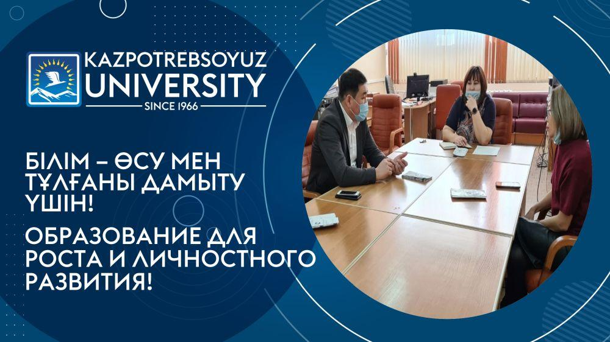
Within the framework of measures to promote youth employment on 24.01.2022, a meeting was held at the Resource Center of the Karaganda University of Kazpotrebsoyuz with the director of the KSU "Employment Center of the Akimat of the city of Karaganda" Nurzhan Syzdykov, head of the Department for Employer Support A.A. Zhakanova and a specialist of the Department for employer support A. Abdrashitova.
At the meeting, representatives of the KSU "Employment Center of the Akimat of the city of Karaganda" (https://instagram.com/czn_karaganda?utm_medium=copy_link) told about the employment programs for young people "Youth practice", "First workplace": advantages, deadlines, wages, etc. Special attention was paid to the introduction of a new register of organizations with a list of vacant vacancies, which will be available to universities from February 2022, which will effectively distribute graduates who studied under the state order, as well as provide information about vacant vacancies to other university graduates.
During the meeting, agreements were reached to improve the effectiveness of cooperation between the Karaganda University of Kazpotrebsoyuz and the Employment Center for the employment of young people in the region.

Employment prospects
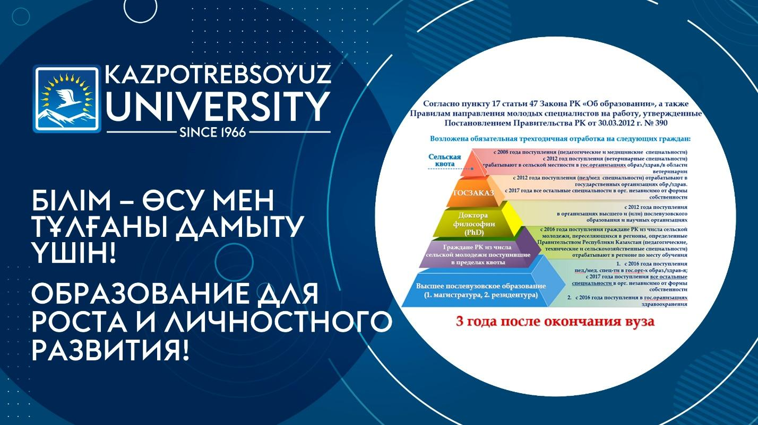
On February 9, 2022, the Resource Center of the Department of Strategic Development organized a meeting with graduates of 2022 (bachelor's degree) studying under the state educational order.
At the meeting, issues of sending young specialists (graduates) and doctors of philosophy (PhD) to work, the implementation of their personal distribution were discussed.
The KaU of Kazpotrebsoyuz has established a commission for the distribution of young specialists and PhD PhDs studying on the basis of the state educational order order No. 33-P dated January 21, 2022.
Director of the RC Sagitova Zh.E. drew the attention of graduates that the distribution is carried out on the basis of the petition (certificate) of the employer about the upcoming employment and the preservation of the vacancy until the young specialist arrives at the place of work. If there are no vacancies at the time of distribution, young specialists are sent by distribution commissions for registration as a job seeker (Public Employment Center), directly to the employment center at the place of residence, taking into account the time they were registered as unemployed in the period of working off .
She noted that young specialists who completed their studies this year arrive at their place of work no later than September 1 in the direction.
Also, students were given explanations in which cases exemption from working off is possible:
1) persons in the absence of vacancies in the locality at the place of residence, work or service of the spouse;
2) disabled people of groups I and II;
3) persons enrolled for further education in the magistracy, residency, doctoral studies;
4) pregnant women, persons who have, as well as independently raising a child (children) under the age of three years.
When entering or calling for urgent military service, a young specialist is granted a deferment for the duration of the service, without offsetting the time of service in the period of working off (Clause 17 of the Resolution of the Government of the Republic of Kazakhstan №390 dated March 30, 2012). In other cases, no delay is provided.
During the meeting, the graduates had the opportunity to get answers to all their questions.

Meeting with representatives of the international group of companies DELTA M
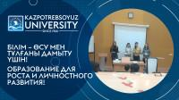
On February 9, 2022, students of the specialties "Jurisprudence", "Customs", "Finance", "Economics" met with representatives of the company DELTA M.
Delta M in the Republic of Kazakhstan is part of the Delta M international group of companies, which has been operating in the field of bad debt management, consulting and automation of collection processes in Eastern Europe and Asia for more than 10 years.
The company has implemented a transparent system of career building and talent support.
With a team of over 150 employees, Delta M is the market leader in NPL recovery.
The company already employs graduates of our university in various management positions, and when selecting candidates, they give preference to graduates of the KarU of Kazpotreboyuz.
The students present at the meeting showed interest and exchanged contacts.

Meeting with representatives of US Service Kazakhstan companies
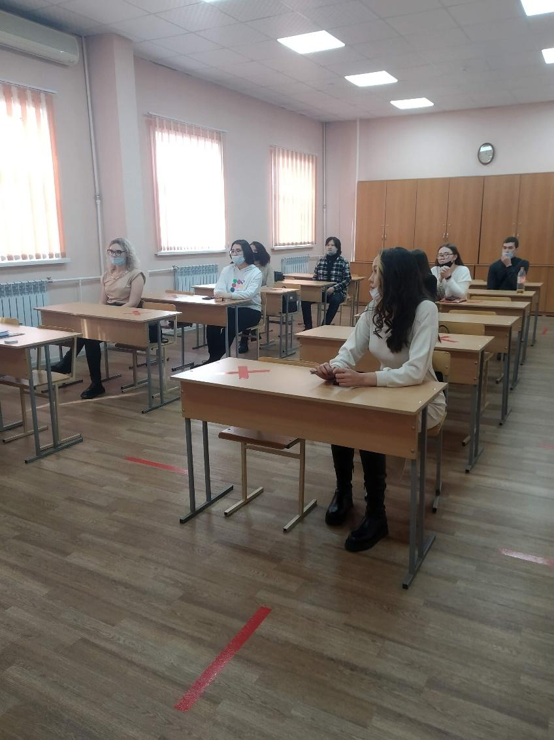
On February 22, 2022, students of the specialty "Accounting and Audit" met with representatives of the company US Service Kazakhstan.
The company "US Service Kazakhstan" LLP is a close-knit team of like-minded people who have been successfully working in Kazakhstan since 2011. The company not only qualitatively does the installation of climate equipment, but also builds cold storage facilities from sandwich panels turnkey. The most modern technologies are used in the construction of warehouses. This allows us to provide the client with the ideal option of providing services in one place.
Representatives of "US Service Kazakhstan" LLP at our university selected accountants for their team, head. warehouses, materialists. The meeting was interesting, lively, the students were active, asked questions to which they received detailed answers.
As a result of the meeting, agreements were reached on the conclusion of contracts for practice, both free and paid.

We are preparing for public service.....
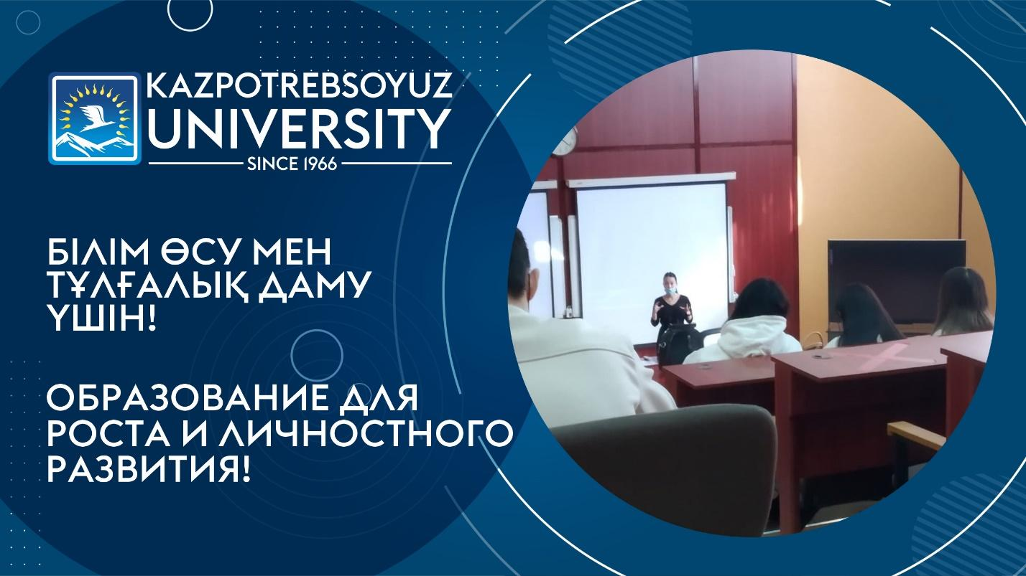
On March 09, 2022, at the Karaganda University of Kazpotrebsoyuz, the Department of the Agency of the Republic of Kazakhstan for Civil Service Affairs in the Karaganda region held a seminar for students of the specialty “State and Local Administration”, dedicated to familiarizing and increasing students' interest in employment in the public service.
The representative of the state institution Magilanova Indira told the students about the criteria for selection for public service, the code of the state employee, and also answered all questions concerning career advancement.
This information is especially relevant for students who plan to enter the civil service.


Cooperation of the Department of Finance with the DGІ of Karaganda
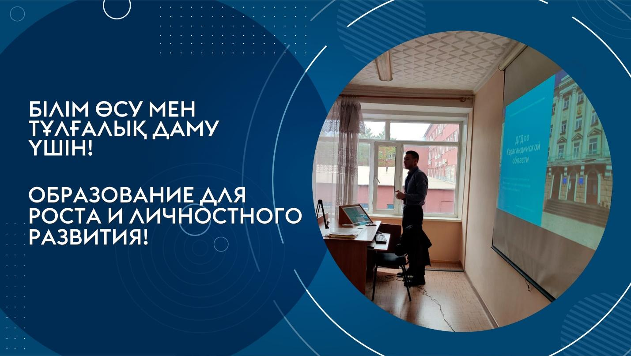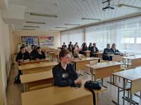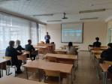
On September 26, 2022, the Department of Finance, within the framework of career guidance, educational work and employment, invited a leading specialist of the Department of State Revenue in the Karaganda region, Zeken Adilkhan Bagdatovich, who conducted a lecture session in groups F-20-2, F-21-4s, UA-20-2, VT-21-4s, ITA-21-4s on the topic "Peculiarities of the work of the State Revenue Department". In his speech, he touched upon the issues of the modern tax system, the rights and obligations of taxpayers and employment prospects in the state revenue system. The lecture was useful for the relationship between the theory and practice of the functioning of the tax sphere.

SUCCESSFUL ENTREPRENEURS OF THE REGION HELD A MEETING WITH STUDENTS
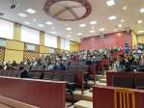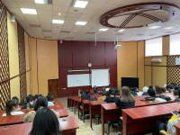
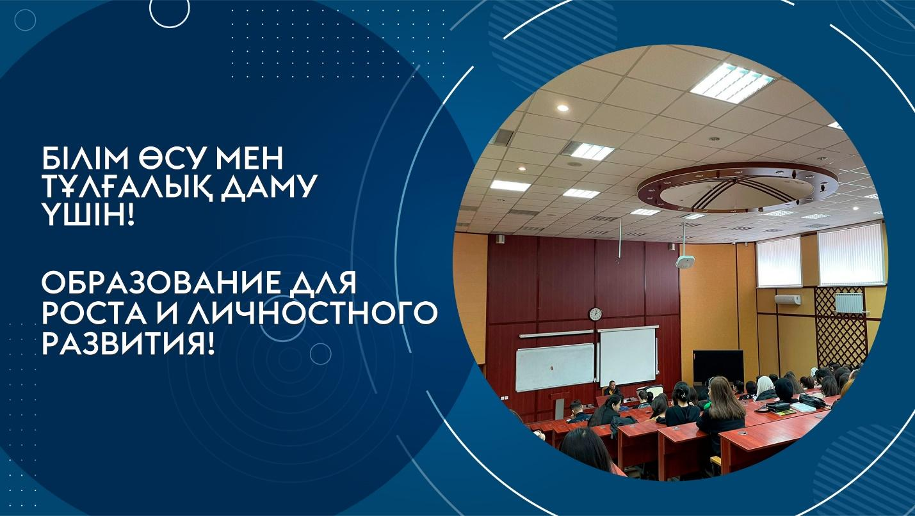
On October 06, 2022, the Resource Center of the Karaganda University of Kazpotrebsoyuz, together with the NCE "Atameken", organized a meeting of graduate students with entrepreneurs of the region, which was attended by the director of the LLP "Organizing Committee of the MCC" Abt Nikolay Viktorovich and the executive director of the LLP "Terricon School" Bulgunaev Baglan Alexandrovich
They shared their experience of creating and running a business, and also told how to avoid mistakes at the initial stage of their own business. they explained where to start their entrepreneurial activity, where to get an idea for their business, how to competently assemble their team and build work with clients.
During the meeting, topical issues of entrepreneurship were discussed, such as:
- Current trends in the development of small and medium-sized businesses;
- Investing in 2022: popular tools, positive and negative trends;
- Modern labor market;
- Hard skills, Soft skills;
- Programs for aspiring entrepreneurs;
- Preferential lending to small businesses, etc.
The meeting with the entrepreneur was fascinating!
Students were interested in questions about how to combine business and study, what difficulties they faced in their entrepreneurial activiti

The "Lesson with entrepreneurs" has passed
at the Karaganda University of Kazpotrebsoyuz
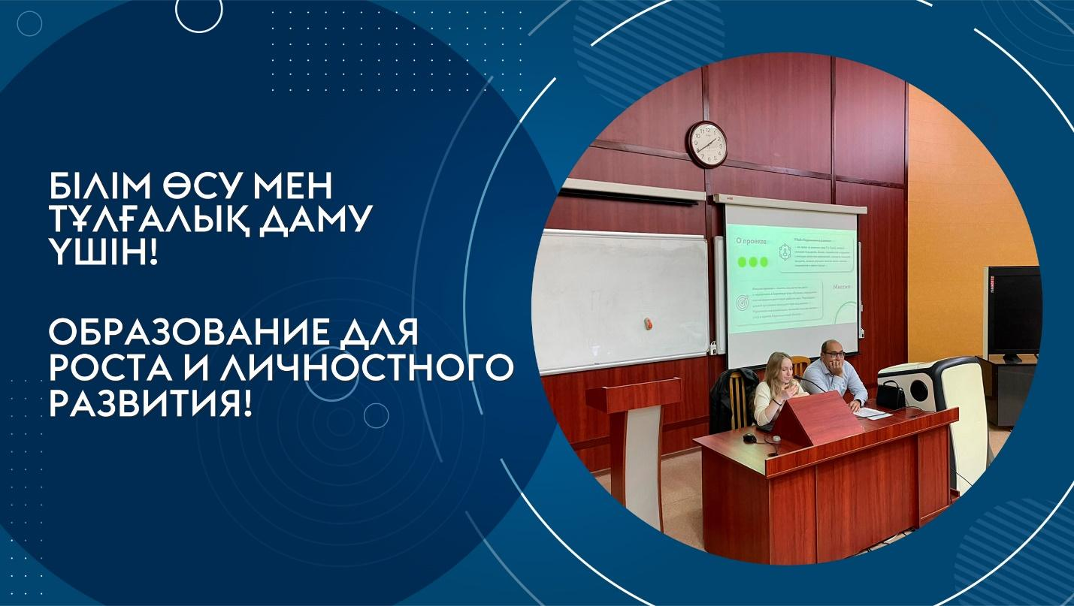
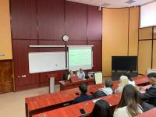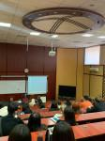
On October 11, 2022, the Resource Center jointly with NCE "Atameken" organized a "Lesson with entrepreneurs" for graduate students, which was attended by:
1) Aleskerov Vladimir Vladimirovich – Director of A.V.Group LLP;
2) Bulgunaev Baglan Alexandrovich – Executive Director of "Terricon School" LLP;
3) Saratovkina Angelina Pavlovna Community Manager of "Terricon Valley" LLP.
Young entrepreneurs and students discussed the prospects for the development of entrepreneurship among young people.
The meeting became a platform for discussing the opportunities available to students interested in starting their own business. Entrepreneurs told about promising directions for starting a business, which formats of doing business are most comfortable at the start, what a university can do for the successful development of student startups and entrepreneurial skills. Students also learned about government support measures available at any stage of business development. During the lesson, the "Professions of the Future" were also discussed, as well as unclaimed professions. Entrepreneurs gave detailed information about the current state of the labor market in our region.
Successful entrepreneurs, being practitioners in their field, are interesting for students, so the lesson was very informative and positive.

Signing of an agreement on the opening of a branch of Karaganda University of Kazpotrebsoyuz on the basis of "QazTehna" LLP
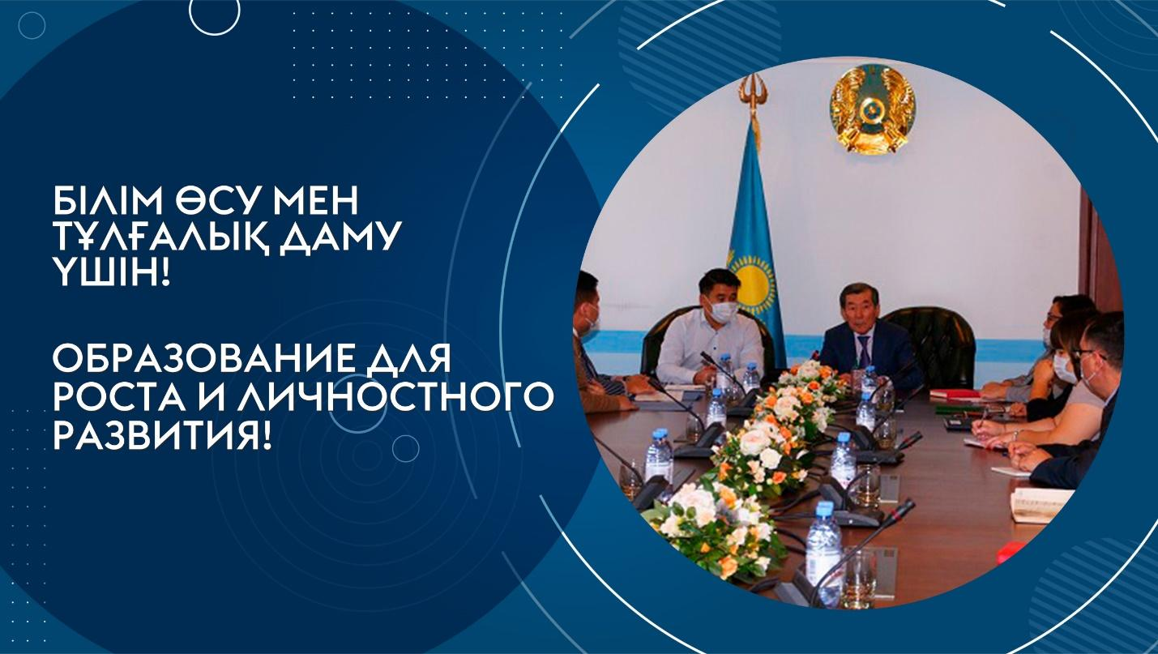
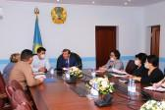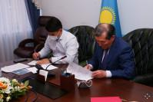
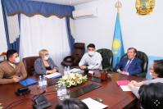
On November 3, 2022, Rector of the University, Doctor of Economics, Professor E.B. Aimagambetov and Deputy General Director of "QazTehna" LLP Omarov E.K. signed an agreement on the opening of a branch of the Karaganda University of Kazpotrebsoyuz on the basis of a large industrial enterprise of the region "QazTehna" LLP (Saran).
On the same day, the heads of organizations signed a roadmap of cooperation between the Karaganda University of Kazpotrebsoyuz and QazTehna LLP, which provides for close cooperation.
The roadmap defines specific activities for 2022-2026, including the organization of internships and internships for university students, conducting courses of additional professional education, developing a dual educational program, conducting joint research and more.

Career Day - 2022
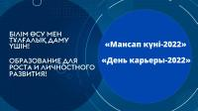
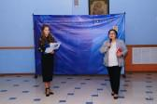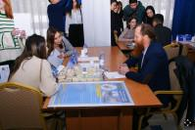
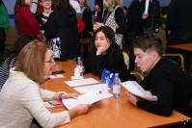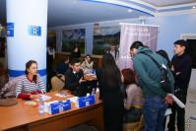
On November 25, 2022, the "Career Day-2022" was held at the university. The event was attended by graduate students and more than 60 employers of various fields of activity, representatives of private and public organizations, such as: the Department of Justice of the Karaganda region, the Prosecutor's Office of the Karaganda region, the Administration of courts in the Karaganda region, the DGD in the Karaganda region, JSC Corporation "Kazakhmys", KSU "Employment Center of the Akimat of the city of Karaganda", "QazTehna" LLP, "Alyp-2008" LLP (supermarket Basket), Bacchus Car Center, "National IT Education Platform" LLP, "Cosmonaut Hotel" LLP, Branches of more than 7 banks, etc.
On the threshold of self—employment and career building, students often have questions, there are many doubts about the correctness of choosing a place of work, etc. Therefore, "Career Day" is an opportunity for graduates to find themselves, their life's work, decide on their future career. Communicating with employers, students not only got acquainted with the activities of leading companies from various industries, also passed quick interviews, received offers for further employment.
This year, the event acquired a digital format: students were registered using a QR code, QR business cards of employers were installed, and a banner "Atlas of New Professions" was developed indicating a QR link with which students could get acquainted with new professions of the future.
"Career Day- 2022" is the largest event aimed at the employment of students.

